TryHackMe – Intro to Log Analysis
Week 3 SOC Analyst Internship | Room 3 Writeup
Room URL: https://tryhackme.com/room/introtologanalysis
Note: Add your own practical outputs, room-specific answers, and screenshots before submission.

1. Objective
- Understand log analysis methodology and best practices.
- Learn tools used to investigate logs and identify suspicious activity.
- Use log evidence to support detection and incident response.

2. Key Concepts
- Logs: Time-sequenced records of events generated by systems, devices, applications, and networks.
- Log analysis: Collecting, parsing, and processing log events to understand activity and identify incidents.
- Timeline: Chronological sequence of events used to reconstruct an incident.
- Super timeline: A combined timeline built from multiple log sources.
- Threat intelligence: Information linked to malicious activity, such as IP addresses, file hashes, and domains.
- Attack signatures: Patterns that may indicate attacks, such as SQL injection strings or repeated failed logins.

3. Common Log Types
Type | Purpose
Application | Application status, warnings, and errors.
Audit | User actions and system changes.
Security | Logins, permission changes, and firewall/security events.
System | Kernel activity, boot events, and system errors.
Network | Connections, communications, and data transfers.
Database | Database queries, updates, and activity.
Web server | Requests, source IPs, URLs, methods, and HTTP response codes.

4. Log Analysis Methodology
- Parsing – Break raw log data into understandable fields.
- Normalisation – Convert different formats into a consistent structure.
- Sorting – Arrange events by time or another useful field.
- Classification – Group events by type, severity, or relevance.
- Enrichment – Add context such as asset details or threat intelligence.
- Correlation – Connect related events from different sources.
- Visualisation – Present patterns using charts, dashboards, or timelines.
- Reporting – Document findings, evidence, impact, and recommendations.

5. Common Log File Locations
- /var/log/syslog – general Linux system messages
- /var/log/auth.log – Linux authentication events
- /var/log/nginx/access.log and /var/log/nginx/error.log – Nginx logs
- /var/log/apache2/access.log and /var/log/apache2/error.log – Apache logs
- /var/log/mysql/error.log – MySQL errors
- /var/log/postgresql/ – PostgreSQL logs

6. Manual vs Automated Analysis
Automated analysis uses tools to process logs and identify patterns. It saves time but may be expensive, produce false positives, or miss unfamiliar events.
Manual analysis means an analyst directly examines logs using commands or text tools. It is inexpensive and allows contextual investigation, but can be slow and may miss events in large datasets.
Room Task 5 answers:
1. A log file is processed by a tool which returns an output: Automated analysis.
2. An analyst opens a log file and searches for events: Manual analysis.

7. Linux Command-Line Tools
cat apache.log
Displays the complete file; useful for short files.
less apache.log
Views a large file page by page; press q to quit.
head apache.log
Displays the first 10 lines by default.
tail apache.log
Displays the last 10 lines by default.
grep "203.64.78.90" apache.log
Finds lines containing the IP address.
grep -v "/index.php" apache.log
Excludes lines containing /index.php.
sed 's/31\/Jul\/2023/July 31, 2023/g' apache.log
Replaces matching date text in output; does not modify the original unless -i is used.
awk '$9 >= 400 {print}' apache.log
Example for displaying Apache-style entries with HTTP status code 400 or higher, when the status code is field 9.

8. Regular Expressions (Regex)
Regex defines patterns for searching, matching, and extracting information from logs.
\b([0-9]{1,3}\.){3}[0-9]{1,3}\b
This simplified pattern matches four groups of one to three digits separated by dots. It does not validate that each IPv4 octet is between 0 and 255.
Example: grep -E 'post=1[0-9]' apache-ex2.log
This searches for blog post IDs from 10 to 19 in the post query parameter.

9. CyberChef
- CyberChef is a browser-based tool for encoding/decoding, hashing, data parsing, and text extraction.
- Operations: choose the processing operation.
- Recipe: ordered list of operations.
- Input: text or file being analyzed.
- Output: result after operations are applied.
- Magic: attempts to identify likely encoding or transformations.
- Example: Base64 text dHJ5aGFja21l decodes to tryhackme.

10. Sigma and YARA
Sigma is an open YAML-based rule format used to describe log detection patterns and help create SIEM searches. A rule can include a title, log source, detection selection, false positives, and severity. Example use case: detect failed SSH logins.
YARA is a pattern-matching tool commonly used in malware analysis. It searches files for strings, byte patterns, and regular-expression patterns. Example use case: a rule named IPFinder searches a text file for IPv4-like strings.

11. Screenshots
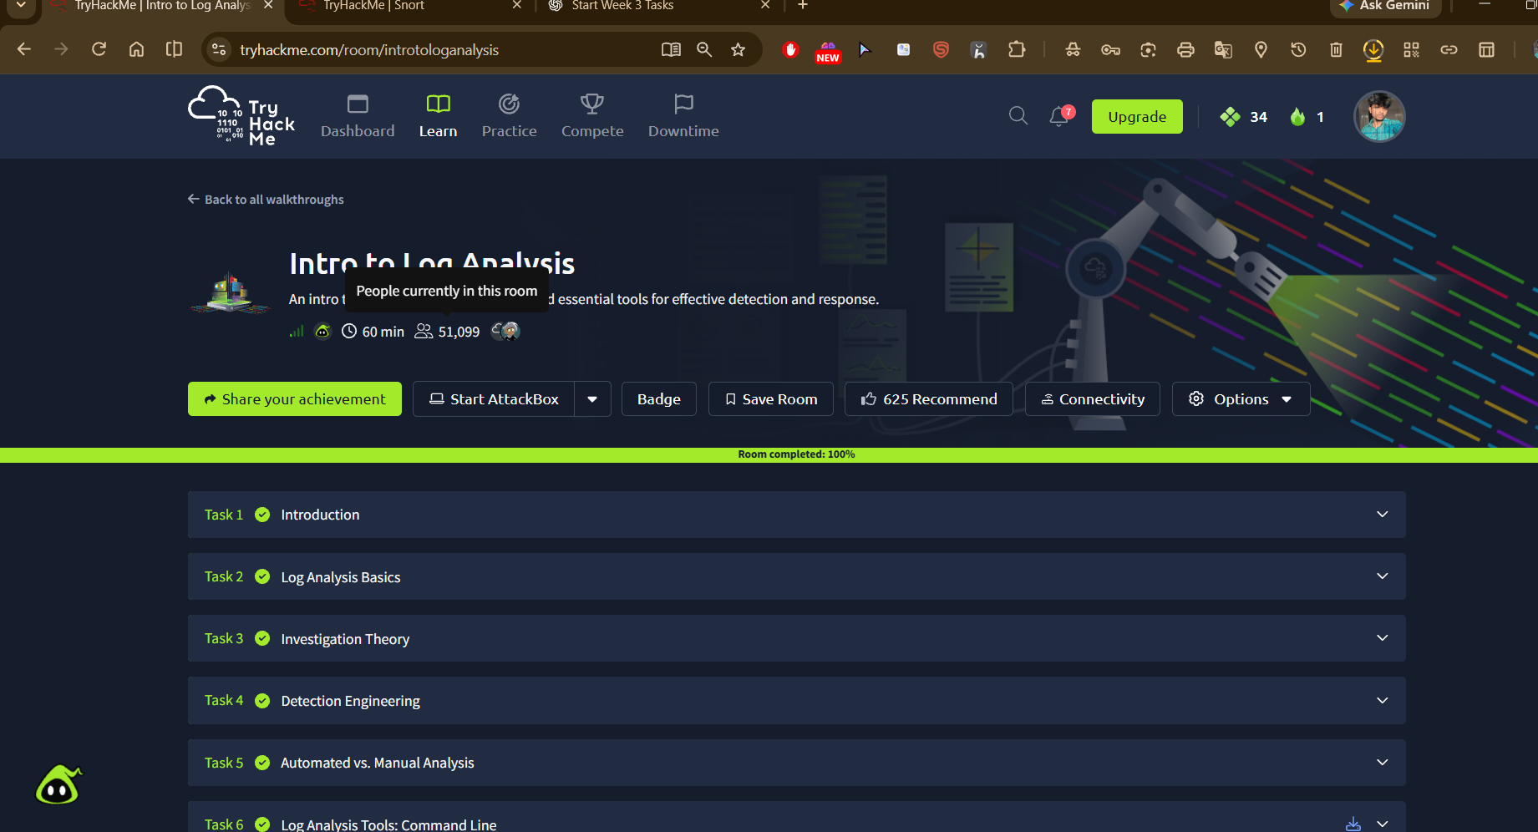

12. Conclusion
This room introduces practical log investigation methods and tools. It explains timelines, attack patterns, manual and automated analysis, Linux commands, Regex, CyberChef, Sigma, and YARA. Add your actual practical findings and screenshots after completing the room.
Reference: TryHackMe – Intro to Log Analysis (room content accessed 2 November 2026).

